Our Services

1. Global Regulated Fund Platform
Helping investment managers, private equity firms, venture capital sponsors, financial institutions and family offices launch, operate and scale regulated investment platforms.
Core Solutions :
- Fund-as-a-Service (FaaS)
Launch and operate your investment fund through our end-to-end regulated platform, without the complexity of building infrastructure from scratch.
- Regulated Fund Hosting
Operate under our licensed regulatory framework, enabling a faster, more efficient route to market while maintaining full regulatory oversight.
- Regulatory Umbrella Platform
Leverage our established regulatory infrastructure to launch compliant investment products across multiple jurisdictions with confidence.
- White-Label Fund Solutions
Bring your investment strategy to market under your own brand while we manage the regulatory, operational, and administrative framework.
- Management Company (ManCo)
Comprehensive management company services covering governance, oversight, regulatory compliance, and operational management throughout the fund lifecycle.
- Portfolio Management
Professional portfolio management solutions focused on disciplined execution, risk management, and alignment with defined investment objectives.
- Fund Governance
Robust governance frameworks designed to strengthen oversight, ensure transparency, and meet the highest regulatory and fiduciary standards.
- Compliance & Risk Management
Integrated compliance and risk management services that help safeguard your fund while ensuring adherence to evolving regulatory requirements.
- AML / KYC & MLRO
Comprehensive AML, KYC, and Money Laundering Reporting Officer (MLRO) services to support regulatory compliance and protect against financial crime.
- Investor Onboarding
A seamless and efficient onboarding process that combines rigorous due diligence with an enhanced investor experience.
- Cross-Border Distribution
Expand your investor reach through compliant cross-border distribution solutions across key international financial markets.
- Capital Markets Infrastructure
Institutional-grade infrastructure supporting efficient fund operations, execution, reporting, and market connectivity.
- Custody & Escrow
Secure custody and escrow solutions designed to protect assets, facilitate transactions, and provide confidence to investors and counterparties.
- SPVs
Structuring and administration of Special Purpose Vehicles (SPVs) for investments, acquisitions, co-investments, and bespoke transaction requirements.
- Structured Finance
Tailored structured finance solutions that optimise capital structures, improve financing efficiency, and support complex transactions.
- Tokenisation & Digital Asset Structures
Innovative digital asset and tokenisation frameworks that enable compliant issuance, management, and administration of next-generation investment products.

2. Our structures

- DIFC Structures
Qualified Investor Fund (QIF)
- Professional investors
- Rapid launch through regulated hosting
- Institutional governance
DIFC Protected Cell Company : copy same as mauritus and relabel as dubai

- Mauritius Structures
Protected Cell Company (PCC)
- Ring-fenced investment cells
- Shared governance
- Country-specific strategies

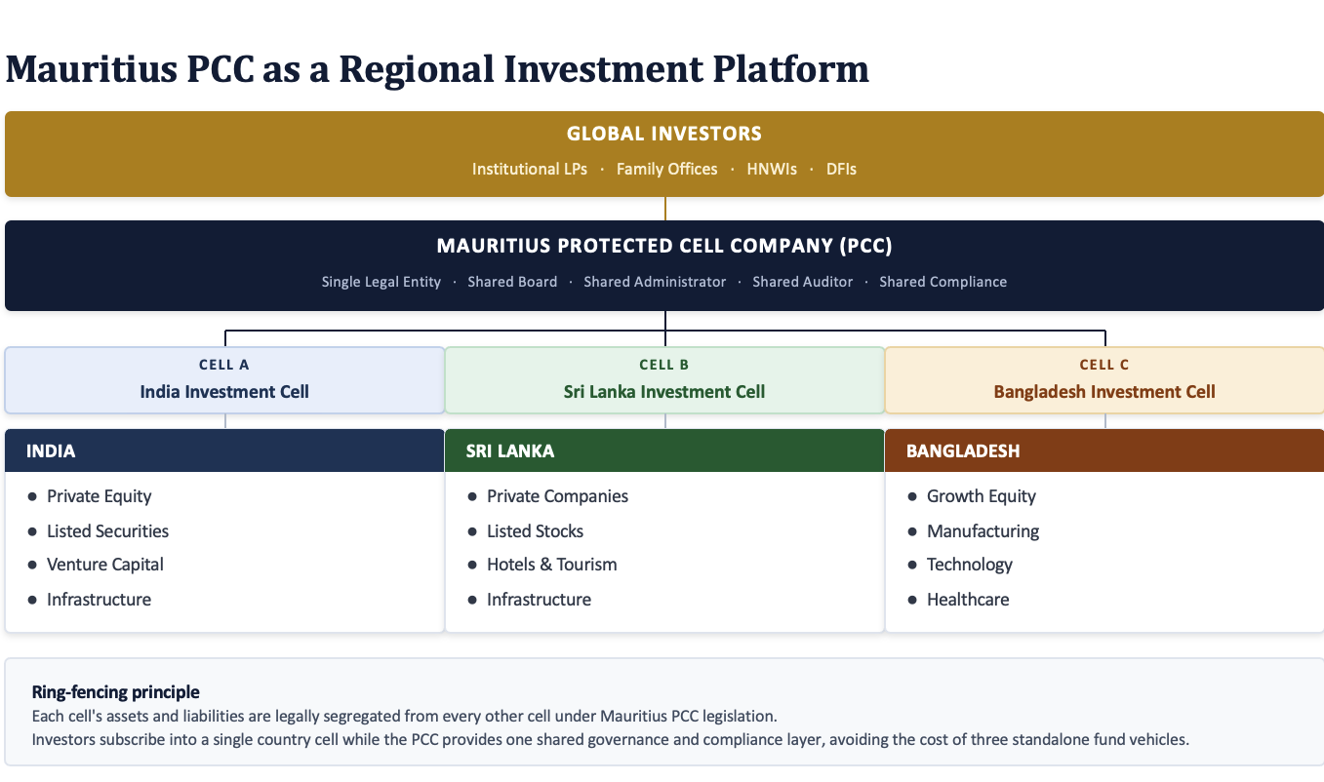

- Luxembourg GP–LP
Ideal for:
- Private equity
- Venture capital
- Institutional fundraising
- European investment strategies

Luxembourg GP–LP Structure

Limited Partners
│
▼
General Partner
│
▼
Investment Fund
│
▼
Portfolio Companies

3. Corporate & Institutional Services Platform
Helping businesses establish, manage and expand internationally.
Core capabilities:
- International Structuring
Design and implement efficient cross-border corporate and investment structures tailored to your commercial, regulatory, and tax objectives.
- Incorporation
Establish companies quickly and efficiently across leading international jurisdictions with end-to-end incorporation support.
- SPVs
Formation and administration of Special Purpose Vehicles (SPVs) for investment holding, acquisitions, financing, and structured transactions.
- Domiciliation
Provide your entity with a registered office and a compliant local presence that satisfies jurisdictional and regulatory requirements.
- Corporate Secretarial
Comprehensive corporate secretarial services to ensure your entity remains compliant with statutory, governance, and filing obligations.
- Directorship
Experienced independent and nominee directors providing effective governance, oversight, and regulatory compliance.
- CFO Services
Outsourced CFO solutions delivering strategic financial leadership, reporting, budgeting, forecasting, and business advisory support.
- Accounting
Accurate and timely accounting services, including bookkeeping, financial reporting, and management accounts tailored to your business needs.
- Payroll
Reliable payroll administration ensuring employees are paid accurately, on time, and in full compliance with local regulations.
- Audit Coordination
End-to-end coordination with auditors to streamline the audit process, enhance efficiency, and ensure timely completion.
- Governance
Robust corporate governance frameworks that promote accountability, transparency, and sound decision-making across your organisation.
- Compliance
Proactive compliance services that help your business meet evolving regulatory obligations while effectively managing operational risk.
Global Corporate Infrastructure

Supporting businesses across:
- UAE
- Singapore
- Hong Kong
- Malaysia
- Mauritius
- Luxembourg
- BVI
- Cayman Islands
- Guernsey
- United Kingdom
With:
- Regulatory compliance
- ESG
- FATCA / CRS
- ESR
- MLRO
- Data protection
- Legal coordination

